**DENTAL HEALTH LESSON #6 VISITING THE DENTIST**

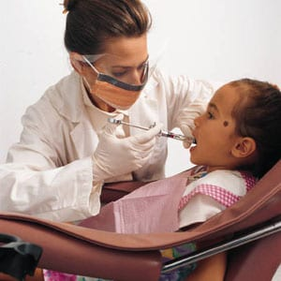

**Hi Kids and Families,**

**Today we are going to talk about the importance of visiting a dentist. How many of you have ever been to a dentist either at school or with your family? You should visit the dentist 2 times a year. With the Coronavirus happening right now, your family will have to schedule an appointment when it is safe. What is a dentist? A dentist is a doctor that checks your teeth and make sure they are healthy. A dentist uses several different types of tools to examine your teeth! Here are some things a dentist might use:**

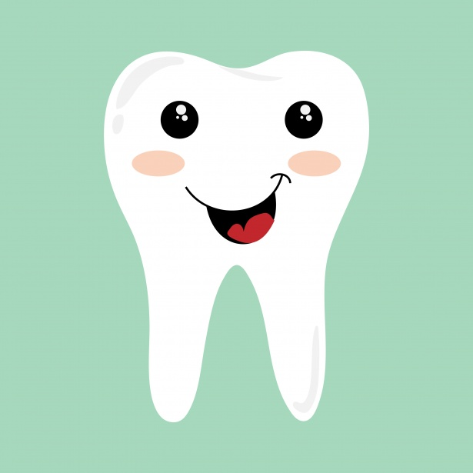

**EXPLORER: this tool helps to count teeth, check for cavities, and scrapes off any plaque that might be on your teeth. Here is a picture of an EXPLORER:**

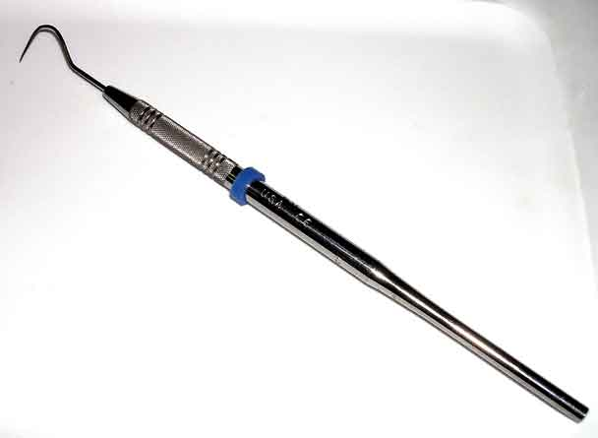

**DENTAL MIRROR: this tool helps the dentist to check all your teeth. The mirror is used to check the tops, bottoms, sides and to see your back teeth! Here is a picture of a MIRROR:**

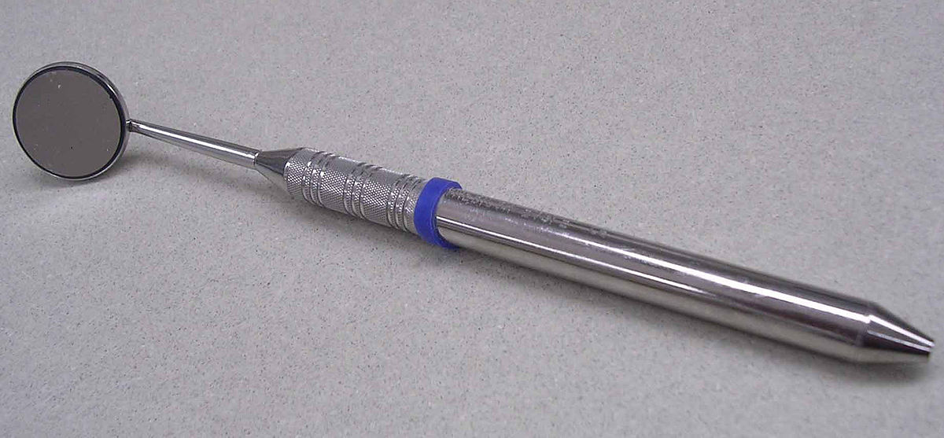

**X-RAY MACHINE: this tool is used to take pictures of your teeth. Dentists can see how your teeth are growing and if there are any cavities underneath. Here is a picture of a DENTAL X- RAY MACHINE:**

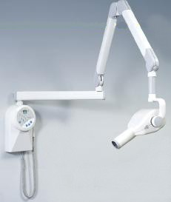

**TOOTH POLISHER: a tooth polisher looks like a toothbrush that the dentist uses to make your teeth nice and clean. Here is a picture of a TOOTH POLISHER:**

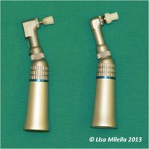

**Please watch the following video about DUDLEY GOING TO THE DENTIST ON YOUTUBE. JUST CLICK ON THE LINK.**

[**https://youtu.be/CnGp7oA9o1A**](https://youtu.be/CnGp7oA9o1A)

**Please email or message on Dojo after you complete the lesson!**

[**MillerA@dvsd.org**](mailto:MillerA@dvsd.org) **or** [**FeissJ@dvsd.org**](mailto:FeissJ@dvsd.org)

**Take Care,**

**Mrs. Miller &Mr. Feiss 😊**